DWARAKA DOSS GOVERDHAN DOSS VAISHNAV COLLEGE (AUTONOMOUS)
ARUMBAKKAM, CHENNAI-600 106



DEPARTMENT OF COMPUTER APPLICATION

ENTERPRISE COMPUTING

DWARAKA DOSS GOVERDHAN DOSS VAISHNAV COLLEGE (AUTONOMOUS)
ARUMBAKKAM, CHENNAI-600 106

DEPARTMENT OF COMPUTER APPLICATION

ENTERPRISE COMPUTING

Certified that this is a record work done by ……………………………………. whose Register no. ………………………… of II M.C.A during the academic year 2010 - 2011.

Faculty In-charge Head of the department

Submitted for practical examination held on ………….…………… at Dwaraka Doss Goverdhan Doss Vaishnav College, Chennai-106.

Internal Examiner External Examiner

S.No | Contents | Page No | Staff’s Sign
1 | Html to Servlet - Bio Data
2 | Servlet to Applet - Passing String
3 | JavaServerPage - Online Quiz
4 | JavaServerPage with JavaBeans -Simple Interest
5 | EnterpriseJavaBean
6 | JavaDataBaseConnection - Pay Roll
7 | RemoteMethodInvocation - Simple Interest
8 | Sending Email

Applet to Servlet Communication

Programs

import java.applet.Applet;
import java.awt.*;
import java.awt.event.*;
import java.net.*;
import java.io.*;
public class cocoa extends Applet implements ActionListener
{ String s[]=new String[10];
int i;
TextArea t1;
Button b1;
URL u;
URLConnection uc;
@Override
public void init()
{
t1=new TextArea("") ;
b1=new Button("click me");

add(t1);
add(b1);
setLayout(new FlowLayout(FlowLayout.LEFT));
b1.addActionListener(this);
try
{
u=new URL("http://localhost:8080/javapp1/mahoo");

}
catch(Exception c)
{

}
}
public void actionPerformed(ActionEvent ae)
{
try
{
uc=u.openConnection();
BufferedReader br =new BufferedReader(new InputStreamReader(uc.getInputStream())) ;
for(i=0;i!='\n';i++)
{
s[i]=br.readLine();
t1.append(s[i]);
}
}
catch(Exception a){}
}
}

import java.io.IOException;
import java.io.PrintWriter;
import javax.servlet.ServletException;
import javax.servlet.annotation.WebServlet;
import javax.servlet.http.HttpServlet;
import javax.servlet.http.HttpServletRequest;
import javax.servlet.http.HttpServletResponse;

public class mahoo extends HttpServlet
{
protected void doGet(HttpServletRequest request, HttpServletResponse response)
throws ServletException, IOException
{
response.setContentType("html/text");
PrintWriter out=response.getWriter();
out.println("welcome"); out.println("to india"); out.println("wish you");
out.println("happy"); out.println("diwali");
} }

Design Window
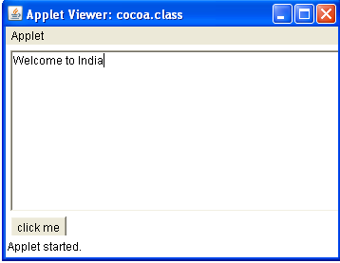
HTML to Servlet Applications
Design Windows

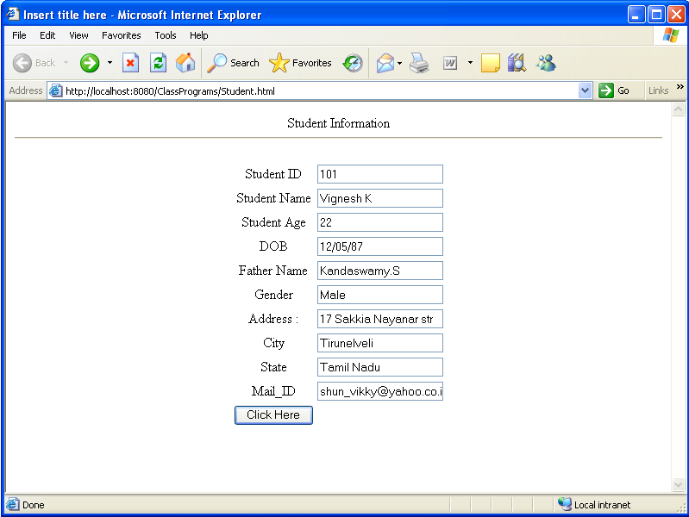

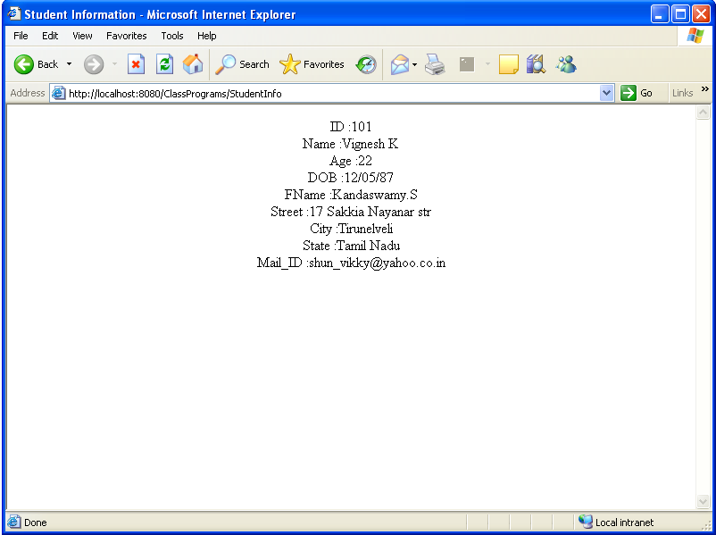

HTML to Servlet Applications

HTML Program

<html>
<head>
<meta http-equiv="Content-Type" content="text/html; charset=ISO-8859-1">
<title>Insert title here</title>
</head>
<body>
<center>Student Information</center>
<hr>
<form action="StudentInfo" method="post">
<Center>
<table border="0">
<tr><td>Student ID</td><td><input type="text" name="id"></input></td></tr>
<tr><td>Student Name</td><td><input type="text" name="name"></input></td></tr>
<tr><td>Student Age</td><td><input type="text" name="age"></input></td></tr>
<tr><td>DOB</td><td><input type="text" name="dob"></input></td></tr>
<tr><td>Father Name</td><td><input type="text" name="fname"></input></td></tr>
<tr><td>Gender </td><td><input type="text" name="gender"></input></td></tr>
<tr><td>Address :</td><td><input type="text" name="street"></input></td></tr>
<tr><td>City</td><td><input type="text" name="city"></input></td></tr>
<tr><td>State</td><td><input type="text" name="state"></input></td></tr>
<tr><td>Mail_ID</td><td><input type="text" name="mailid"></input></td></tr>
<tr><td colspan="1"><input type="submit" name="submit" value="Click Here"></input></td></tr>
</table>
</center>
</form>
</body>
</html>

JAVA Program

Studentinfo (file name)

package htmltoservlet;

import java.io.IOException;
import java.io.PrintWriter;
import javax.servlet.ServletException;
import javax.servlet.annotation.WebServlet;
import javax.servlet.http.HttpServlet;
import javax.servlet.http.HttpServletRequest;
import javax.servlet.http.HttpServletResponse;

public class StudentInfo extends HttpServlet {

protected void processRequest(HttpServletRequest request, HttpServletResponse response)
throws ServletException, IOException {
response.setContentType("text/html;charset=UTF-8");
PrintWriter out = response.getWriter();
try {
String id,sname,age,dob,gender,fname,street,city,state,mailid;
id=request.getParameter("id");
sname=request.getParameter("name");
age=request.getParameter("age");
dob=request.getParameter("dob");
gender=request.getParameter("gender");
fname= request.getParameter("fname");
street=request.getParameter("street");
city=request.getParameter("city");
state=request.getParameter("state");
mailid=request.getParameter("mailid");
response.setContentType("text/html");
out.println("<html><head><title>Student Information</title></head>");
out.println("<body>");
out.println("<center>");
out.println("ID :"+id+"<br>");
out.println("Name :"+sname+"<br>");
out.println("Age :"+age+"<br>");
out.println("DOB :"+dob+"<br>");
out.println("FName :"+fname+"<br>");
out.println("Street :"+street+"<br>");
out.println("City :"+city+"<br>");
out.println("State :"+state+"<br>");
out.println("Mail_ID :"+mailid+"<br>");
out.println("</center>");
out.println("</body></html>");

} finally {
out.close();
}
Creating JSP program using Java Beans
(Simple Interest)
Design Window
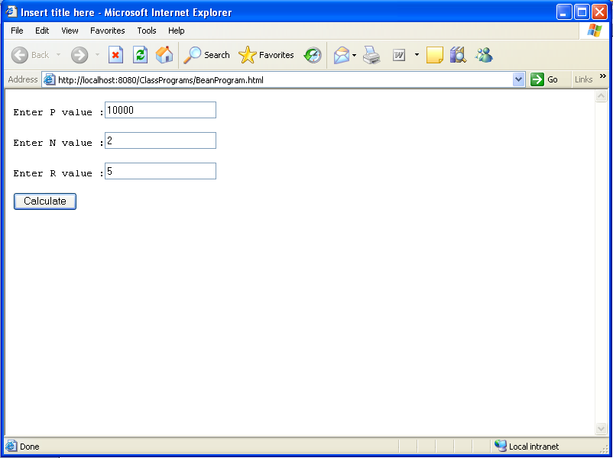

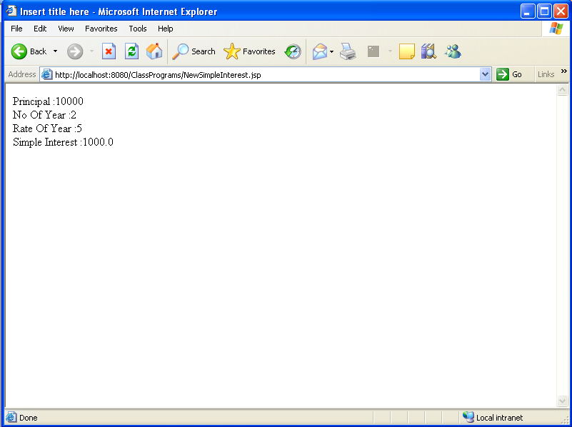
Creating JSP program using Java Beans

HTML Program

<html>
<head>
<meta http-equiv="Content-Type" content="text/html; charset=ISO-8859-1">
<title>Insert title here</title>
</head>
<body>
<form action="NewSimpleInterest.jsp" method="post">
<pre>
Enter P value :<input type="text" name="p"></input><br>
Enter N value :<input type="text" name="n"></input><br>
Enter R value :<input type="text" name="r"></input><br>
<input Type="submit" name="submit" value="Calculate"></input><br>
</pre>
</form>
</body>
</html>

JSP Program

Newsimpleinterest.jsp

<html>
<head>
<meta http-equiv="Content-Type" content="text/html; charset=ISO-8859-1">
<title>Insert title here</title>
</head>
<body>
<jsp:useBean id="simple" class="javabean.Simple" scope="session">
<jsp:setProperty name="simple" property="p"/>
<jsp:setProperty name="simple" property="n"/>
<jsp:setProperty name="simple" property="r"/>
Principal :<jsp:getProperty name="simple" property="p"/><br>
No Of Year :<jsp:getProperty name="simple" property="n"/><br>
Rate Of Year :<jsp:getProperty name="simple" property="r"/><br>
Simple Interest :<jsp:getProperty name="simple" property="result"/><br>
</jsp:useBean>
</body>
</html>

Java Bean

Javabean.simple

package javabean;

public class Simple {
private int p,n,r;
private double result;

public double getResult() {
return ((p*n*r)/100);
}

public int getP() {
return p;
}

public void setP(int p) {
this.p = p;
}

public int getN() {
return n;
}

public void setN(int n) {
this.n = n;
}

public int getR() {
return r;
}

public void setR(int r) {
this.r = r;
}
}

Performing Java Database Connectivity

HTML Program

<html>
<head>
<meta http-equiv="Content-Type" content="text/html; charset=ISO-8859-1">
<title>Insert title here</title>
</head>
<center><h1>Employee Information</h1></center>
<body>
<form action="calculate.jsp" method="post">
<center>
Emp ID <input type="text" name="eid"></input><br>
Emp Name <input type="text" name="ename"></input><br>
Emp Age <input type="text" name="eage"></input><br>
Gender <input type="text" name="gender"></input><br>
BasicPay <input type="text" name="basicpay"></input><br>
<input type="submit" name="submit" value="INSERT"></input>&nbsp;&nbsp;&nbsp;&nbsp;<input type="submit" name="submit" value="UPDATE"></input><br>
<input type="submit" name="submit" value="DELETE"></input>&nbsp;&nbsp;&nbsp;&nbsp;<input type="reset" name="reset" value="CLEAR"></input><br>

</center>
</form>

JSP Program

<%@page import="payroll.JdbcPay"%>
<jsp:include page="emminfo.html"/>
<html>
<head>
<meta http-equiv="Content-Type" content="text/html; charset=ISO-8859-1">
<title>Insert title here</title>
</head>
<body>
<%
String ename,gender,insert;
int eid,eage;
double basicpay,hra,cca,da,pa,tax,pf,gp,np;

ename=request.getParameter("ename");
gender=request.getParameter("gender");

eid=Integer.parseInt(request.getParameter("eid"));
eage=Integer.parseInt(request.getParameter("eage"));

basicpay=Double.parseDouble(request.getParameter("basicpay"));
insert=request.getParameter("submit");
hra=(basicpay*(15.0/100));
cca=(basicpay*(3.0/100));
da=(basicpay*(1.5/100));
pa=(basicpay*(1.7/100));
tax=(basicpay*(5.0/100));
pf=(basicpay*(8.0/100));
gp=(basicpay+cca+da+pa);
np=(gp-(tax+pf));

try{
JdbcPay jp=new JdbcPay();

if(insert.equalsIgnoreCase("insert"))
{
jp.setEid(eid);
jp.setEname(ename);
jp.setGender(gender);
jp.setEage(eage);
jp.setBasicpay(basicpay);
jp.setHra(hra);
jp.setCca(cca);
jp.setDa(da);
jp.setPa(pa);
jp.setTax(tax);
jp.setPf(pf);
jp.setGp(gp);
jp.setNp(np);
jp.insert();
out.println("Data was Inserted");
}
else if(insert.equalsIgnoreCase("update"))
{
jp.setEid(eid);
jp.setEname(ename);
jp.setGender(gender);
jp.setEage(eage);
jp.setBasicpay(basicpay);
jp.setHra(hra);
jp.setCca(cca);
jp.setDa(da);
jp.setPa(pa);
jp.setTax(tax);
jp.setPf(pf);
jp.setGp(gp);
jp.setNp(np);
jp.update();
out.println("Data was Updated");
}
else if(insert.equalsIgnoreCase("delete"))
{
jp.setEid(eid);
jp.delete();
out.println("Records was Deleted");
}
}catch(Exception e)
{out.println(e);}
%>

</body>
</html>

Java Bean

package payroll;
import java.sql.*;

public class JdbcPay {

public String query;
private String ename,gender;
private int eid,eage;
private double basicpay;
private double hra,cca,da,pa,tax,pf,gp,np;
Connection c;
Statement s;
ResultSet rs;

public JdbcPay()throws Exception
{
Class.forName("sun.jdbc.odbc.JdbcOdbcDriver");
c=DriverManager.getConnection("jdbc:odbc:emp");
s=c.createStatement();
}

public void insert()throws Exception
{
query="insert into empinfo values("+eid+",'"+ename+"',"+eage+",'"+gender+"',"+basicpay+","+hra+","+cca+","+da+","+pa+","+tax+","+pf+","+gp+","+np+")";
int i=s.executeUpdate(query);
if(i==1)
{
System.out.println("data was inserted");
}
}

public void update()throws Exception
{
query="update empinfo set ename='"+ename+"',age="+eage+",gender='"+gender+"',basicpay="+basicpay+",hra="+hra+",cca="+cca+",pa="+pa+",tax="+tax+",pf="+pf+",gp="+gp+",np="+np+" where eid="+eid+"";
int i=s.executeUpdate(query);
if(i==1)
{
System.out.println("Data was Updated");
}
}

public void delete() throws Exception
{
query="delete from empinfo where eid="+eid+"";
System.out.println(query);
int i=s.executeUpdate(query);
if(i==1)
{

System.out.println("Data was Deleted");
}
}

public double getHra() {
return hra;
}

public double getCca() {
return cca;
}

public double getDa() {
return da;
}

public double getPa() {
return pa;
}

public double getTax() {
return tax;
}

public double getPf() {
return pf;
}

public double getGp() {
return gp;
}

public double getNp() {
return np;
}

public void setHra(double hra) {
this.hra = hra;
}

public void setCca(double cca) {
this.cca = cca;
}

public void setDa(double da) {
this.da = da;
}

public void setPa(double pa) {
this.pa = pa;
}

public void setTax(double tax) {
this.tax = tax;
}

public void setPf(double pf) {
this.pf = pf;
}

public void setGp(double gp) {
this.gp = gp;
}

public void setNp(double np) {
this.np = np;
}

public String getEname() {
return ename;
}
public void setEname(String ename) {
this.ename = ename;
}
public String getGender() {
return gender;
}
public void setGender(String gender) {
this.gender = gender;
}
public int getEid() {
return eid;
}
public void setEid(int eid) {
this.eid = eid;
}
public int getEage() {
return eage;
}
public void setEage(int eage) {
this.eage = eage;
}
public double getBasicpay() {
return basicpay;
}
public void setBasicpay(double basicpay) {
this.basicpay = basicpay;
calc();
}
public void calc ()
{
hra=(basicpay*(15.0/100));
cca=(basicpay*(3.0/100));
da=(basicpay*(1.5/100));
pa=(basicpay*(1.7/100));
tax=(basicpay*(5.0/100));
pf=(basicpay*(8.0/100));
gp=(basicpay+cca+da+pa);
np=(gp-(tax+pf));
}

}

Performing Java Database Connectivity

Design Window

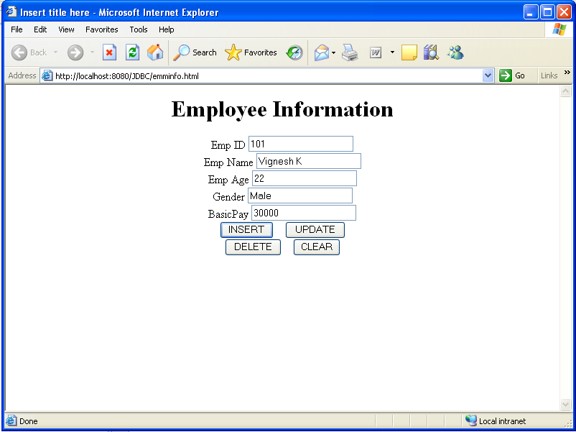

Remote Method Invocation

Simple Interest:

Server:
import java.rmi.server.*;
import java.rmi.*;
import java.io.*;
public class server22 extends UnicastRemoteObject implements arithmetics
{
public server22() throws Exception
{
}
public double si(double d1,double d2,double d3) throws RemoteException
{
return d1*d2*d3/100;
}
public static void main(String args[])
{
try
{
server22 ss=new server22();
Naming.rebind("test",ss);
System.out.println("server started");
}
catch(Exception e)
{
System.out.println("Error"+e);
}
}
}

Client:
import java.rmi.*;
import java.io.*;
public class client22
{
public static void main(String args[]) throws IOException
{
try
{
BufferedReader br=new BufferedReader(new InputStreamReader(System.in));
arithmetics in=(arithmetics)Naming.lookup("test");
System.out.print("enter prinicpal value:");
String a=br.readLine();
double x=Double.parseDouble(a);
System.out.print("enter year value:");
String b=br.readLine();
double y=Double.parseDouble(b);
System.out.print("enter rate of interest value:");
String c=br.readLine();
double xx=Double.parseDouble(c);
System.out.println("the result is"+in.si(x,y,xx));
}
catch(Exception e)
{
System.out.println("client"+e);
}}}

Interface:
import java.rmi.*;
public interface arithmetics extends Remote
{
public double si(double d1,double d2,double d3) throws RemoteException;
}

OUTPUT:

C:\Program Files\Java\jdk1.6.0\bin>start rmiregistry

server
C:\Program Files\Java\jdk1.6.0\bin>javac server22.java
C:\Program Files\Java\jdk1.6.0\bin> java server22
server started

Client
C:\Program Files\Java\jdk1.6.0\bin>java client22
enter prinicpal value:1000
enter year value:2
enter rate of interest value:5
the result is100.0

Enterprises Java Bean

Output Window

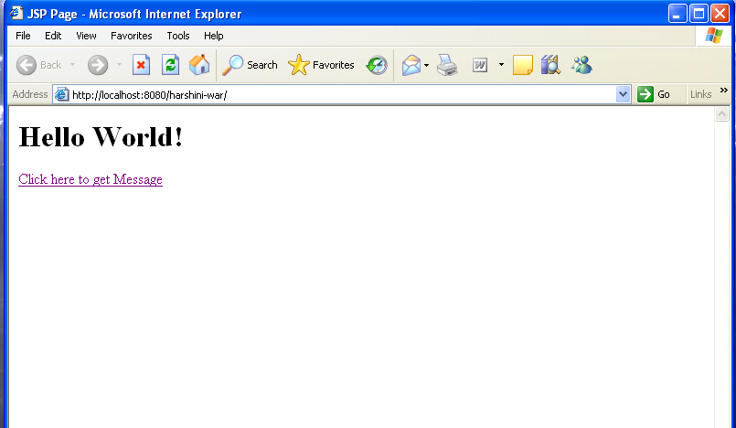

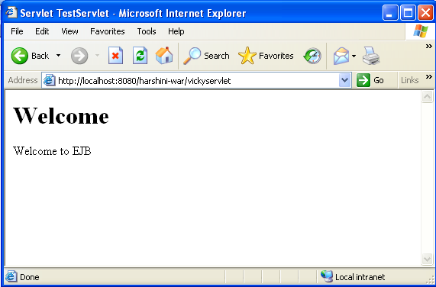

EJB:

package vicky;

import javax.ejb.Stateless;

public class vickybean implements vickybeanRemote {

public String businessMethod() {
return "Welcome to EJB";
}
}

Java Servlet:

package vvv;

import java.io.IOException;
import java.io.PrintWriter;
import vicky.vickybeanRemote;
import javax.ejb.EJB;
import javax.servlet.*;
import javax.servlet.http.*;

@WebServlet(name="vickyservlet", urlPatterns={"/vickyservlet"})
public class vickyservlet extends HttpServlet {
@EJB
private vickybeanRemote vbr;
protected void processRequest(HttpServletRequest request, HttpServletResponse response)
throws ServletException, IOException {
response.setContentType("text/html;charset=UTF-8");
PrintWriter out = response.getWriter();
try {
out.println("<html>");
out.println("<head>");
out.println("<title>Servlet TestServlet</title>");
out.println("</head>");
out.println("<body>");
out.println("<h1>Welcome</h1>");
out.println(vbr.businessMethod());
out.println("</body>");
out.println("</html>");
} finally { out.close(); } } }

JSP Program:

<%@page contentType="text/html" pageEncoding="UTF-8"%>
<!DOCTYPE HTML PUBLIC "-//W3C//DTD HTML 4.01 Transitional//EN"
"http://www.w3.org/TR/html4/loose.dtd">

<html>
<head>
<meta http-equiv="Content-Type" content="text/html; charset=UTF-8">
<title>JSP Page</title>
</head>
<body>
<h1>Hello World!</h1>
<a href="vickyservlet">Click here to get Message</a>
</body>
</html>

SENDING EMAIL
File Name SendEmail.java
import java.util.*;
import javax.mail.*;
import javax.mail.internet.*;
import javax.activation.*;

public class SendEmail
{
public static void main(String [] args)
{

String to = "abcd@gmail.com";

String from = "web@gmail.com";

String host = "localhost";

Properties properties = System.getProperties();

properties.setProperty("mail.smtp.host", host);

Session session = Session.getDefaultInstance(properties);

try{
MimeMessage message = new MimeMessage(session);
message.setFrom(new InternetAddress(from));
message.addRecipient(Message.RecipientType.TO,
new InternetAddress(to));
message.setSubject("This is the Subject Line!");
message.setText("This is actual message");
Transport.send(message);
System.out.println("Sent message successfully....");
}catch (MessagingException mex) {
mex.printStackTrace();
}
}
}

